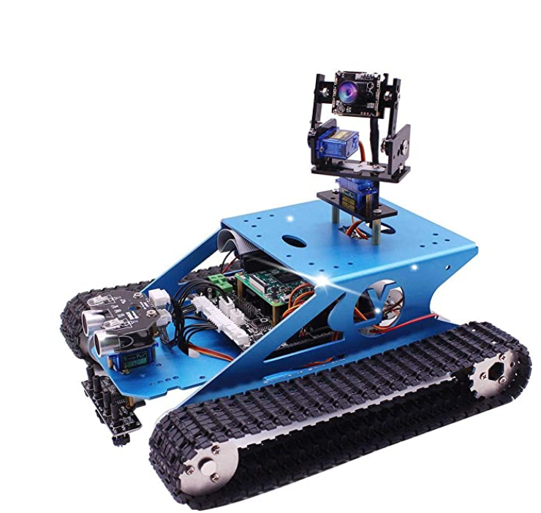***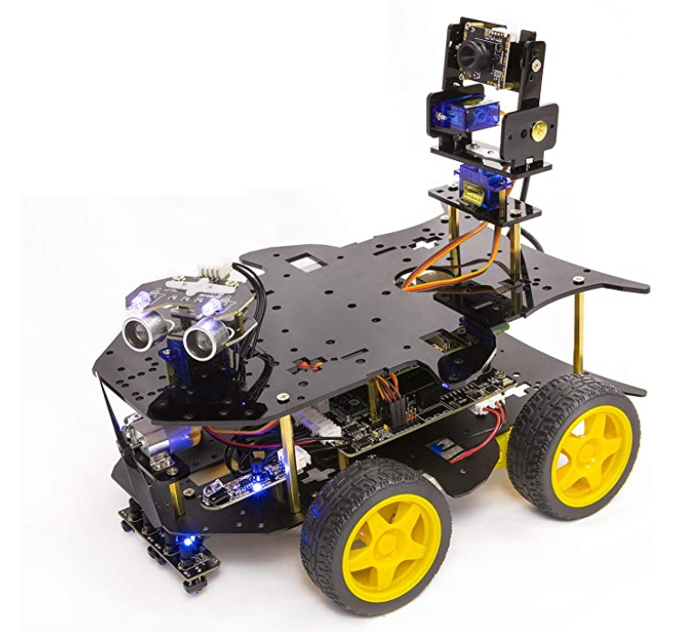Project Report***

(Specifically for teams that chose to receive one of two robot kits and work individually to roughly approximate the original team-based goal of the Police Academy robot. Your robot should navigate a homemade course of tape or cardboard walls, identify an eas-to-identify object, and knock it down. Submit report and video on canvas.)

The report should be of sufficient detail that a person skilled at the level of a Mechatronics graduate could understand, reproduce and modify your design. Labeled digital photos and well-commented code listings should accompany your descriptions of each subsystem that makes up your robot. Clear, complete and concise are your goals. Since you have not designed the chassis or sensors, you can describe them very briefly. Focus on documenting the work you have done, with flow or block diagrams to explain the code. Also include of lessons-learned, which other kit buyers might find valuable. As a rule of thumb, the body of the report should be around 3-4 pages, with mostly labeled diagrams and text to support them, and a maximum of 5 pages of appendices (if your code is much longer, link to a github or place it in a google drive and share it with me).

I would suggest an outline as follows, but feel free to modify as you see fit:

1. Introduction and Project Requirements
2. Modifications Made to your Kit (if any)
3. Code
   1. Block or Flow Diagrams
   2. Explanation of Modules or Libraries Included
   3. Systems Integration – Issues and Resolution
4. Results
   1. Describe progress and results
   2. Future work, beyond this project
   3. Advice for future kits users
5. Citations
6. Appendix
   1. Code
   2. Other technical support